Quiz 4 TensorFlow/Keras
(total 20 points, with 6 points for the last question)

- Which of the following activities are performed by TensorFlow?
  - Data automation
  - Model tracking
  - Model retraining
  - Performance monitoring
  - All of the above
Answer: E

- How many types of models does Keras provide?
  - 2
  - 3
  - 4
  - 5
Answer: B

- Which of the following Keras models is known to be the simplest model and it constitutes a linear set of layers?
  - Sequential Model
  - Advanced Model
Answer: A

- Which of the following methods is used to add layers in a sequential model?
  - Layers_add()
  - Add_layers()
  - Add()
  - Layers()
Answer: C

- How many parameters does the compilation process take in Keras?
  - 3
  - 5
  - 9
  - 6
Answer: A

- What is LSTM?
  - Longitude short-term memory
  - Long short-term memory
  - Lengthy short-term memory
Answer: B

- Models with shared layers, multi-outputs, and directed acyclic graphs can be defined using the _?
  - Keras functional API
  - Keras sequential API
Answer: A

- To implement a densely-connected network, which of the following model gives better results?
  - Sequential model
  - Advanced model
Answer: A

- which Keras layer would you use if you want to reduce overfitting in neural network models?
  - Pooling layer
  - Dropout layer
  - Permute layer
  - Lambda layer
Answer: B

- In Keras, "sequential" refers to a ?
  - Single layer

  - Multiple layers
  - Entire model
Answer: C

- To train your model in Keras, which of the following methods would you use?
  - Predict()
  - Model()
  - Fit()
Answer: C

- To predict your model, which of the following methods would you use?
  - Predict()
  - Model()
  - Fit()
Answer: A

- Which functions in Keras help you to find faults or deviations in the learning process?
  - Keras optimizer function
  - Keras metrics
  - Keras loss function
Answer: C

- Which of the following permits you to evaluate the performance of your model?
  - Keras optimizer function
  - Keras metrics
  - Keras loss function
Answer: B

- How many parameters are there in the following Keras neural network model (show your work of calculations)?

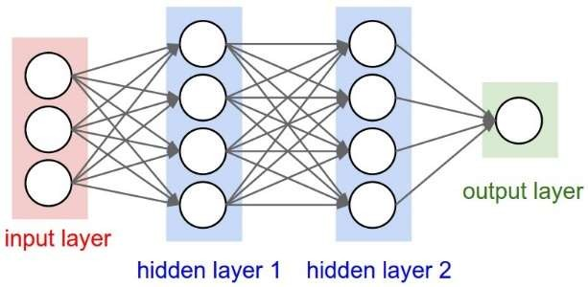

Answer: Input to Hidden Layer 1: (I nodes * H1 nodes) + H1 biases
Hidden Layer 1 to Hidden Layer 2: (H1 nodes * H2 nodes) + H2 biases
Hidden Layer 2 to Output Layer: (H2 nodes * 1 node) + 1 bias

The neural network has a total of 41 parameters. Here's the breakdown:

Input to Hidden Layer 1: 3×4+4=16 parameters (12 weights + 4 biases)
Hidden Layer 1 to Hidden Layer 2: 4×4+4=20 parameters (16 weights + 4 biases)
Hidden Layer 2 to Output Layer: 4×1+1=5 parameters (4 weights + 1 bias)

Adding 16+20+5 = 41 parameters.

